**PROJECT REPORT ON**

**STREAMIINED EMPLOYEE DETAIL MANAGEMENT**

**(DEVELOPER)-(LONG TERM)**

**Introduction:**

The project aim is to provide real-time knowledge for all the students who have basic knowledge of Salesforce and Looking for a real-time project. This project will also help those professionals who are in cross-technology and want to switch to Salesforce. With the help of this project they will gain knowledge and can include it into their resume as well.

**Milestone 01** -**CreatingDeveloper Org**

* Go to developer.salesforce.com
* Click on sign up.
* On the sign up form, enter the following details
* First name & Last name –Divvela lakshmidhar yadav
* Email :yadavlakshmidhar@gmail.com
* Role –SALESFORCE DEVELOPER
* Company – GAYATRI DEGREE COLLEGE – TIRUPATI
* Country - India
* Postal Code – pin code 517501
* Username – yadavlakshmidhar@gdctirupathi

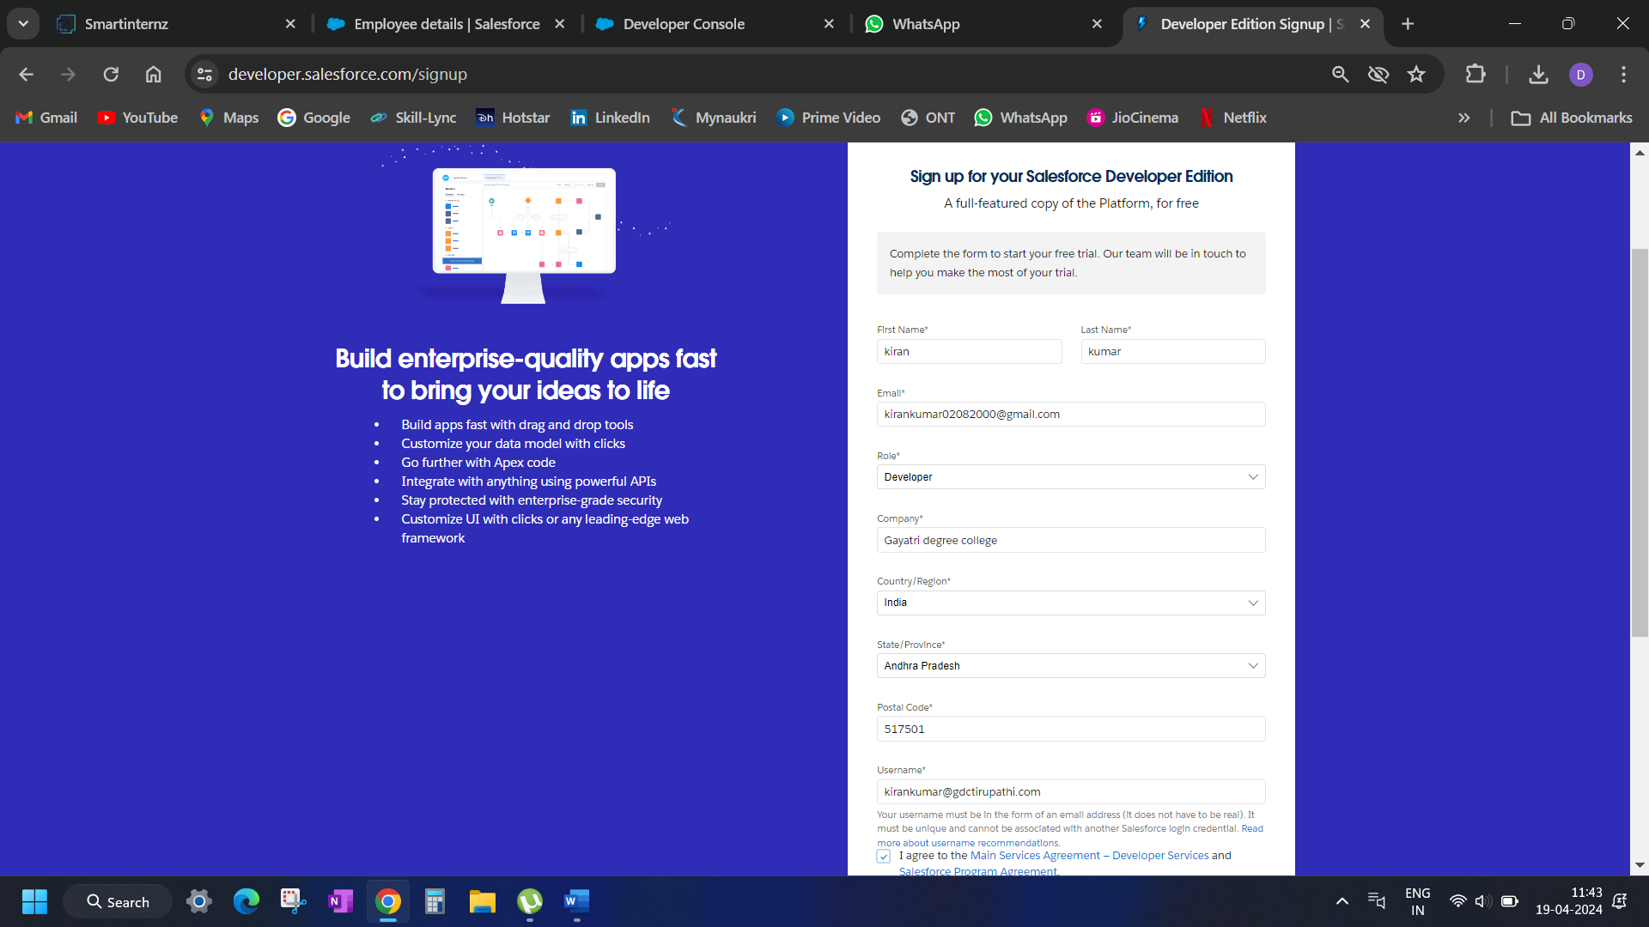

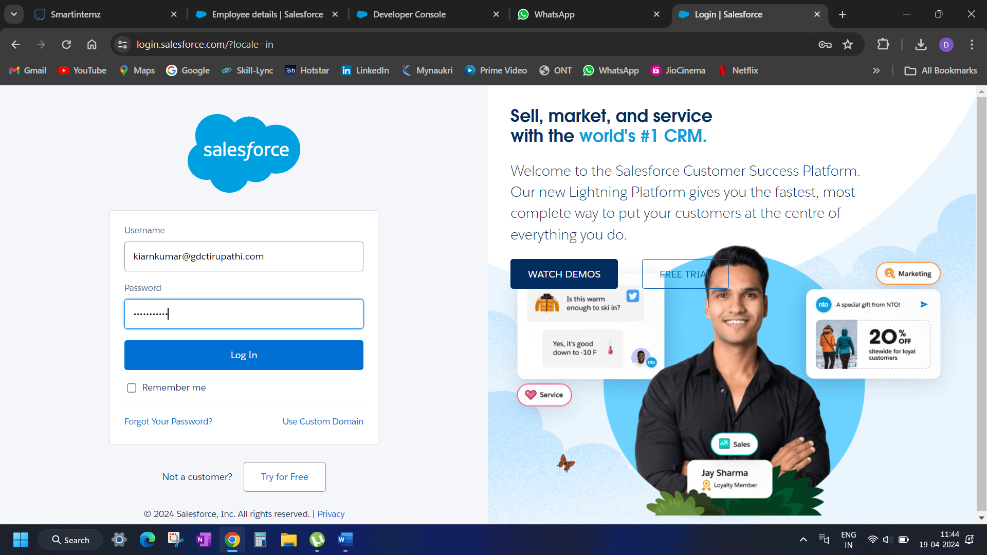

**Milestone 02 –Creation of Object**

Click on gear icon >>> click setup

1. From the setup page ? Click on Object Manager ? Click on Create ? Click on Custom Object
2. On Custom object defining page:  
   3. Enter the label name, plural label name, click on Allow reports, Allow search.
3. 4. Click on Save.

1. From the setup page ? Click on Object Manager ? Click on Create ? Click on Custom Object.

2. On Custom object defining page:  
3. Enter the label name, plural label name, click on Allow reports, Allow search.

4. Click on Save. 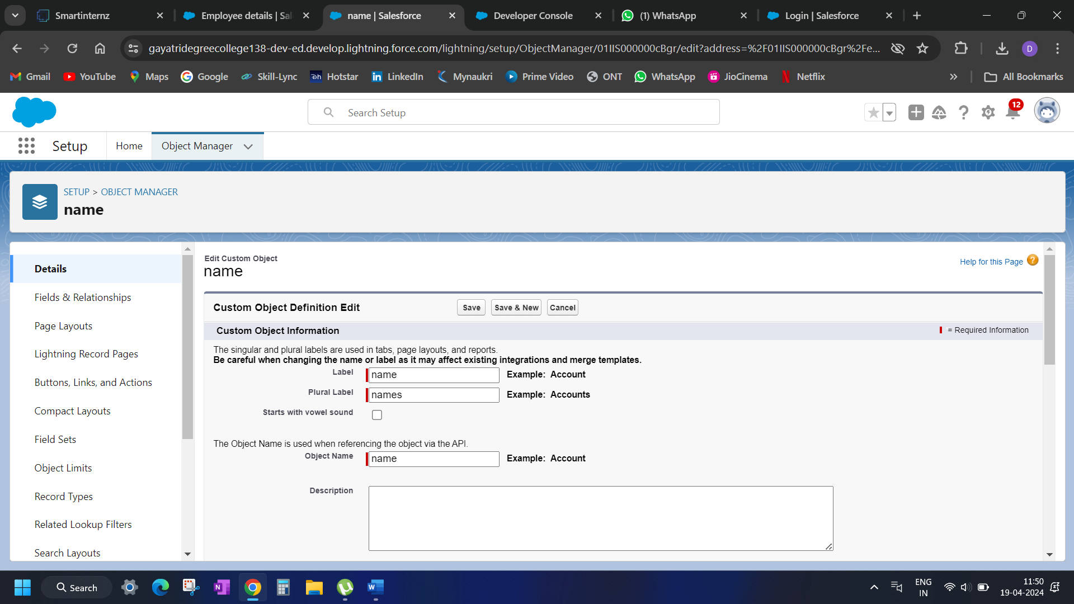

**Milestone 03 TABS**

What is Tab ?

 A tab is like a user interface that is used to build records for objects and to view the records in the objects.

Types of Tabs:

1. Custom Tabs

Custom object tabs are the user interface for custom applications that you build in salesforce.com. They look and behave like standard salesforce.com tabs such as accounts, contacts, and opportunities.

1. Web Tabs

Web Tabs are custom tabs that display web content or applications embedded in the salesforce.com window. Web tabs make it easier for your users to quickly access content and applications they frequently use without leaving the salesforce.com application.

1. Visualforce Tabs

Visualforce Tabs are custom tabs that display a Visualforce page. Visualforce tabs look and behave like standard salesforce.com tabs such as accounts, contacts, and opportunities.

1. Lightning Component Tabs

Lightning Component tabs allow you to add Lightning components to the navigation menu in Lightning Experience and the mobile app.

1. Lightning Page Tabs

Lightning Page Tabs let you add Lightning Pages to the mobile app navigation menu.

Lightning Page tabs don't work like other custom tabs. Once created, they don't show up on the All Tabs page when you click the Plus icon that appears to the right of your current tabs. Lightning Page tabs also don't show up in the Available Tabs list when you customize the tabs for your apps.

*Creation of tabs

Go to setup page ? type Tabs in Quick Find bar ? click on tabs ? New (under custom object tab)

1. Select Object(Employee) ? Select the tab style ? Next (Add to profiles page) keep it as default ? Next (Add to Custom App)  uncheck the include tab .
2. Make sure that the Append tab to users' existing personal customizations is checked
3. Click Save

**Milestone 04 THE LIGHTING APP**

**\*CREATION OF LIGHTING APP**

1. Go to setup page ? search “app manager” in quick find ? select “app manager” ? click on New lightning App.

##### **. Fill the app name in app details as Employee Mapp >>> Next  >>> (App option page) keep it as default >>> Next >>> (Utility           Items) keep it as default >>> Next.**

##### **3. To Add Navigation Items: Select the items (Employee, Organization, Health Insurances, Leave ) from the search bar and                   move it using the arrow button >>> Next.**

##### 

**Milestone 05 FIELDS**

##### **When we talk about Salesforce, Fields represent the data stored in the columns of a relational database. It can also hold any valuable information that you require for a specific object. Hence, the overall searching, deletion, and editing of the records become simpler and quicker.**

##### **Types of Fields**

##### **1. Standard Fields**

##### **2. Custom Fields**

##### 

##### **Standard Fields:**

##### 

##### **As the name suggests, the Standard Fields are the predefined fields in Salesforce that perform a standard task. The main point is that you can’t simply delete a Standard Field until it is a non-required standard field. Otherwise, users have the option to delete them at any point from the application freely. Moreover, we have some fields that you will find common in every Salesforce application.**

##### **They are,**

##### **? Created By**

##### **? Owner**

##### **? Last Modified**

##### **? Field Made During object Creation**

Custom Fields:

##### **On the other side of the coin, Custom Fields are highly flexible, and users can change them according to requirements. Moreover, each organizer or company can use them if necessary. It means you need not always include them in the records, unlike Standard fields. Hence, the final decision depends on the user, and he can add/remove Custom Fields of any given form.**

*CREATION JUNCTION OBJECT

##### **A Junction  object is a custom object that serves as a bridge between two related objects in a  many-to-many relationship. It allows you to create a relationship between records of two different objects by creating a many-to-many relationship model. Creating junction object as Employee details with Organization & Health Insurance To create junction object**

*CREATION A MASTER DETAIL RELATIONSHIP

Master-detail relationship is a type of relationship between two objects where the master object controls certain behaviors and settings of the detail object. Here are a few use cases that demonstrate the use of master-detail relationships

1. Go to the setup page >>> click on object manager >>> From drop down click edit for  Employee object.

2. Click on fields & relationship >>> click on New.

 3. Select “Master-Detail relationship” as data type and click Next.

1. Select the related object “ Organization ” and click nex
2. 5. Next ? Next ? Save & New.

**Milestone 07 – EMAIL TEMPLATES**

1. We use email templates to increase productivity and ensure consistent messaging. Email templates with merge fields let you quickly send emails that include field data from Salesforce records like contacts, leads, or opportunities. You can use email templates when emailing groups of people—with list email or mass email—or just one person.
2. Salesforce email templates are the easiest way to get your emails done. They help you create and send quick emails that include merge fields from Salesforce records like Contacts, Leads, Opportunities, or Custom Objects.
3. When you have a large number of contacts or leads in Salesforce, it can be difficult to keep track of whoneeds to be notified about new information. Salesforce email templates allow you to combine all these contacts or leads into one email and then send it out simultaneously.

*CREATION EMAIL TEMPLATE FOR EMEGENCY LEAVE APPORAL

##### **To create Email Template: 1.  Go to App launcher ? click on Email Template. 2.  Click on “Email Templates” ? New Email Template. 3.  Email Template Name is “Emergency Leave Approved” 4. Related Entity Type ? Employee 5.  Description “Your emergency leave was approved”. 6.  Folder “Public Email Templates”. 7.  Subject “Your Emergency leave was approved” 8.  In the HTML text enter the given information and click save.**

Dear {{{Employee__c.Name}}}

I hope this email finds you well. We wanted to inform you that your emergency leave request has been approved.

Please ensure that all pending tasks are delegated, and you have completed any necessary handovers before proceeding on your leave.

During your absence, if any urgent matters arise or if there is a need for any further assistance, please contact the Manager.

**Milestone 08 – USERS**

A user is anyone who logs in to Salesforce. Users are employees at your company, such as sales reps, managers, and IT specialists, who need access to the company's records. Every user in Salesforce has a user account. The user account identifies the user, and the user account settings determine what features and records the user can access.  
Each user account contains at least the following:

* Username
* Email Address
* User's First Name (optional)
* User's Last Name
* Alias
* Nickname
* License
* Profile
* Role (optional)

**\*creatre user**

Go to setup >>> type users in quick find box >>> select users >>> click New user.

Fill in the fields

##### **1. First Name: Racheal**

  2. Last Name: Marc

  3. Alias: Give a Alias Name

  4. Email id: Give your Personal Email id

  5. Username: Username should be in this form: text@text.text

  6. Nick Name: Give a Nickname

  7. Role: SVP, Human Resources

  8.User license: Salesforce Platform

  9.Profiles: Standard Platform User

 10. Save.

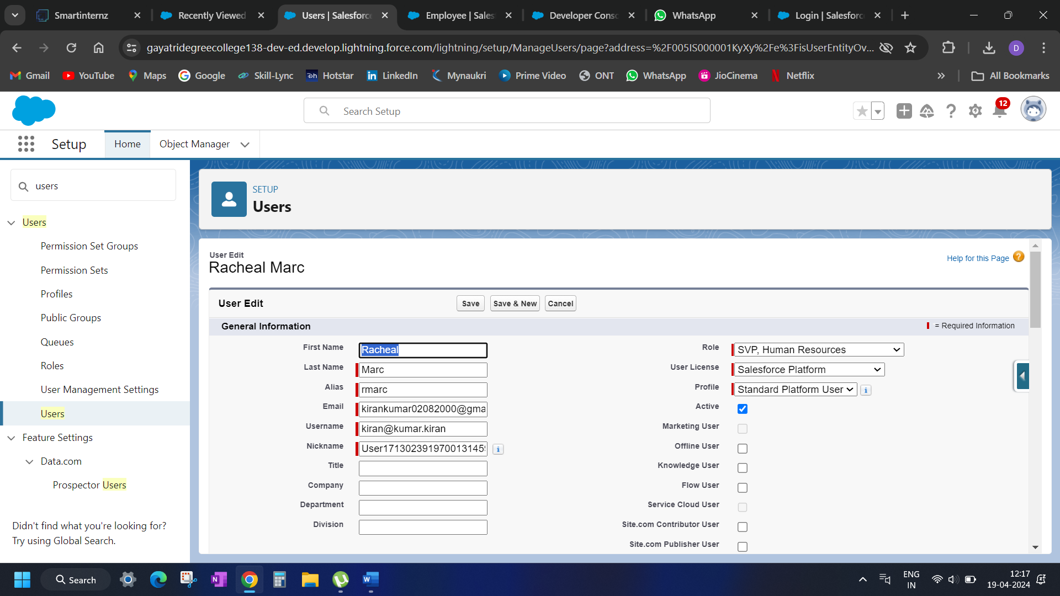

**Milestone 09 APPROVAL PROCESS**

* **Create on approval process for emergency leave**
* To create fields in an object:
* 1.Go to setup >>> Approval Processes in quick find bar >>> click on it.

##### **2.Manage Approval Process For >>> “Leave” from the drop down**

##### **3.Click on “Create New Approval  Process” >>> Use standard setup wizard. 4. Process Name “Emergency Leave Approval” >>> Click Next.**

##### **5. Field “Leave: Leave Type” >>> Operator : equals, Value >>> Click on the lookup filter   icon and select “Emergency Leave”. 6.Click insert field, then click Next.**

##### **. Field “Leave: Leave Type” >>> Operator : equals, Value >>> Click on the lookup    filter icon and select “Emergency Leave”.**

8. Next Automated Approver determined by “Manager” from the drop down.

    Use approver field of leave owner should be marked as check.

9. Select the “Administrators ONLY can edit records during the approval  process”.Then Next.

10. Under the Approval Assignment Email Template click in the lookup  icon >>> Lightning >>> Public Email Templates                       “Emergency Leave Approved”. Then Next.

. From the available fields select >>> LeaveID, and then add >>> Add it to the selected Fields. Similarly add the Owner,                     LeaveType, Status. Then Next.

* Make sure Display approver history is checked.
* And under security settings check the “Allow approvers to access the approval page only from within the Salesforce application. (Recommended)” option.

12. Submitter type Search >>> Owner, Allowed Submitters >>> Leave Owner. Then Next.

* Make sure Allow submitters to recall approval requests is checked.
* Then click save.
* Once you have saved your approval process, while on the same page click   the  approval process.
* 14. At the approval steps, Click on “New Approval Step”.
* 17. Automatically assign to approvers is to be selected. User: from the lookup give the user.
* 18. “Approve or reject based on the FIRST response” is to be selected. Then click save.
* .While on the same Approval Process page .Under the “Final Approval Action” click Add New from the drop down select                 “Email  Alert”.
* 0. Description: Your  emergency leave request was approved. Unique name is auto populated.
* 21. Email Template, click the lookup option and  select Emergency Leave Approved.
* 22. Recipient Type : User, Selected Recipient : Leave Owner. Then click save.
* A screenshot of a computer

  Description automatically generated

**Milestone 10 –FLOWS**

Creation of flow shift start

1. Go to setup >>> type Flow in quick find box >>> Click on the Flow and Select the New Flow.
2. Select the record Triggered flow. Click on create.

##### **4. Select Free Form Layout for the flow and then Click on the Manager option, You will find “New Resource”**

##### **5. Select “Text Template”**

##### **6. Then API name should be filled as “Email Body”, And enter the given details in it**

##### **{!Emailbody}**

Just a quick note to inform you that your shift has now started. We're excited to have you on board and ready to make a positive impact today!

Should you need any support or have any questions during your shift, don't hesitate to reach out to your team members or supervisor.

Health Issues If Any: {!$Record.Health_Issues_If_Any__c}

Existing Insurance: {!$Record.Existing_Health_Insurance__c}

Travel Allowance: {!$Record.Travel_Allowance__c}

7. Click “New Resource” under manager.

8. Select “Text Template”

9. Then API name should be filled as “Subject”.And enter the given details in it (Hi this is to inform you that your

    shift has just started.) Make sure it is “view as plain text”.

10. Click Done.

##### **Drag the  “Action” element from the toolbox onto the screen.**

##### **12. Under Category dropdown select Email, Then in the action bar select “ Send Email ” action.**

13. Give API name as “Shift Started”.

       14. Change the toggle to “Include the Body” Select {!Emailbody} from the dropdown.

      15. Change the toggle to “Include the Subject” Select{!Subject} from the dropdown.

      16. Change the toggle for recipient address list to include. From the dropdown select “{!$Record.Email_Id__c}”

      17. And then click save, and click on activate.

**Milestone 11 – Apex**

1. Go to Setup --> Click on the gear icon --> Select Developer Console..
2. Then we can see the Developer console. Click on the developer console and you will navigate to a new console window.
3. To create a new Apex Class follow the below steps:  
   Click on the file --> New --> Apex Class.
4. Give the Apex Class name as “PhnValid_PassengerObj”.
5. Click ok.
6. Now write the code logic here
7. 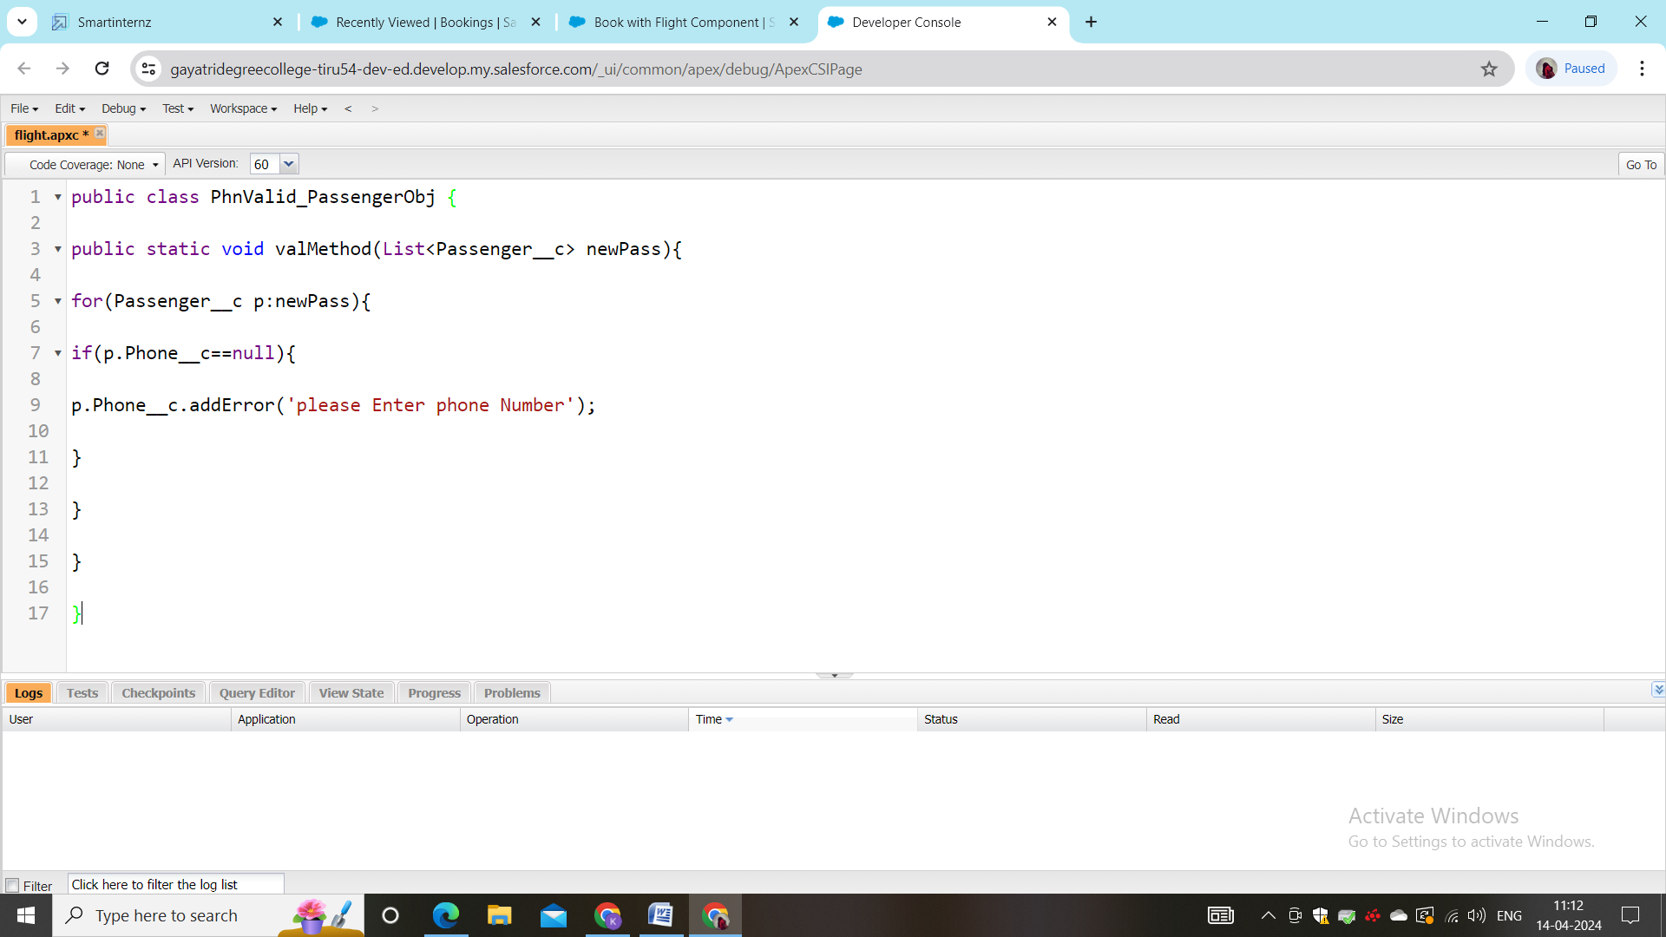

Milestone 12-user adoption

*creation for the employee object

1. Go to App Launcher >>> click on Employee Mapp.
2. Click on the employee Tab .Click on New.
3. 4. Give the employee name, email, date of birth, gender, salary all the fields are to be filled including shift timings.
4. 5. Make sure you fill the location in terms of latitude and longitude as shown below.
5. 6.  Then click save and new.(Similarly create more records in the employee object)
6. 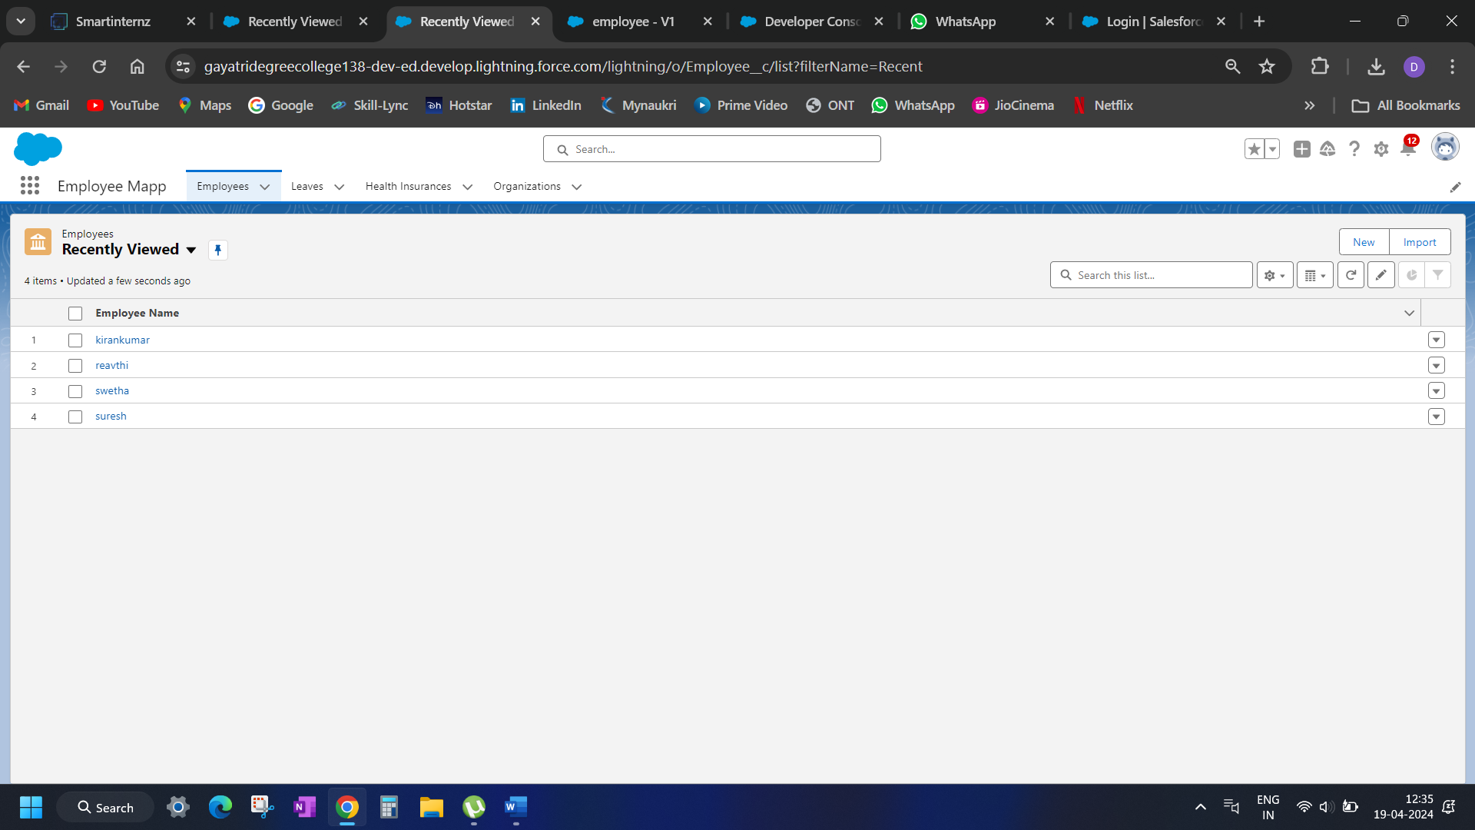

MILESTONE 13 REPORTS

1. Go to the app >>> click on the reports tab

2. Click New Report.

3. Select report type from category or from report type panel or from search panel >>>    click on start report.

4. Select report >>> Employees with Organizations with Travel Allowances , Then click on start report.

5. Once you click on start report you will see that the records you have created would be displayed.

6.Group the columns according to your preference from the dropdown as shown.

7. Save your report as Travel Allowance Report. And run it.

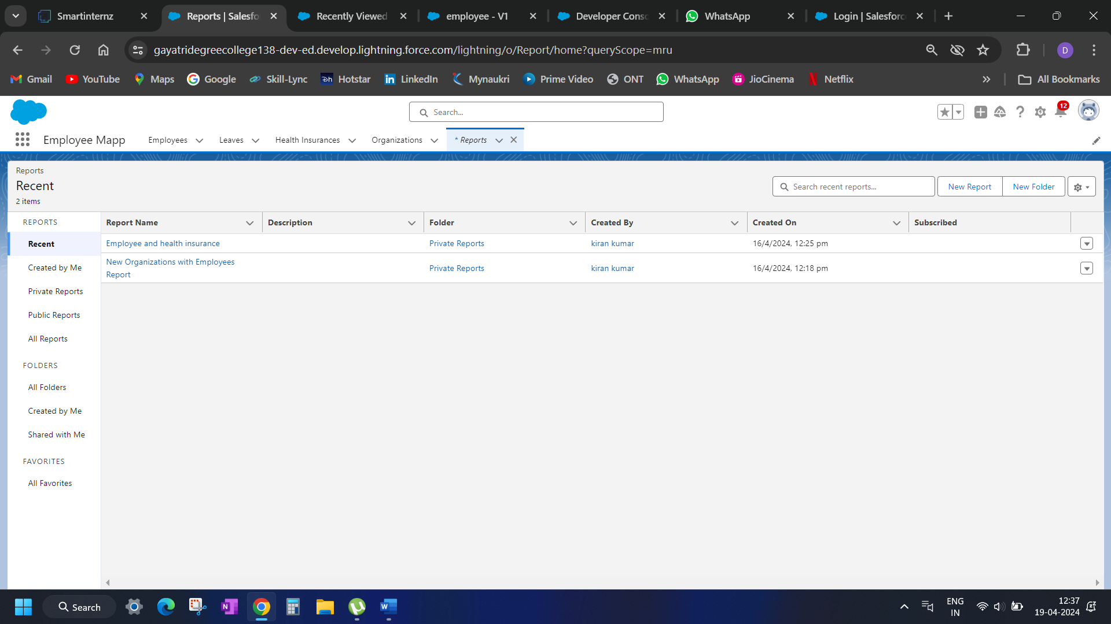

MILESTONE 14 DASHBOARDS

Go to the app >>> click on the Dashboards tabs.

Give a Name and click on Create.

##### **Select a Report and click on select.**

##### **5. Add the component on the dashboard.**

##### **6. Click save then done.**

MILESTONE 15 APEX

*CREATION of tirggers

1. Login to the trailhead account and navigate to the gear account in the top right corner.

2. Then we can see the Developer console. Click on the developer console and you will navigate to a new console window.

3. Then you can see many tools in the Toolbar of the new console window. Click on File, New and Apex Trigger.

4.  Enter the name “LeaveTrigger” select the sObject from the list “leave__c”.

##### **5. Enter the given code in the console, check for errors and save.**

##### **trigger LeaveTrigger on Leave__c (before insert) {**

##### **if(trigger.isBefore){**

##### **if(trigger.isInsert){**

##### **LeaveTriggerHandler.ifMaleEmployee(trigger.new);**

##### **}**

##### **}  }**

THE END